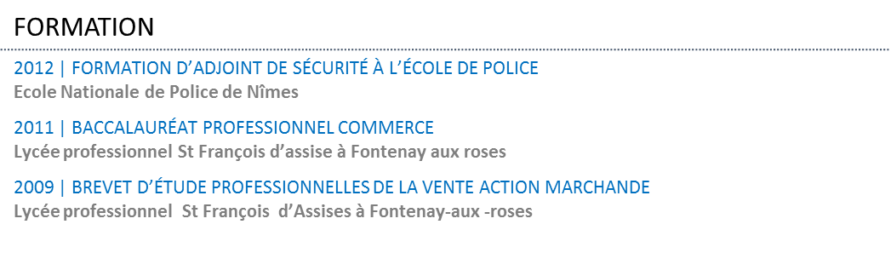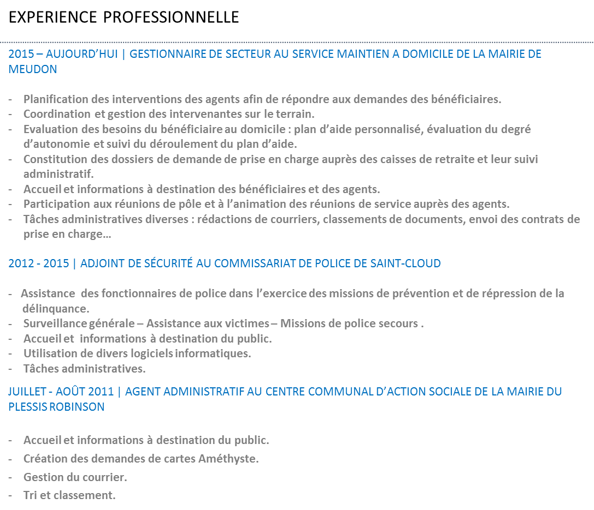

Andréa LE BAIL

18/09/1991

[andrealebail@hotmail.fr](mailto:andrealebail@hotmail.fr)

6 Square Hector Malot

92350 Le Plessis Robinson

06 59 62 74 71

Permis B